**Exercise: Add and Stylize Markers**

*Coding Exercise*

Replace the icon markers we added in the previous lectures with circle markers shown in the screenshot below:

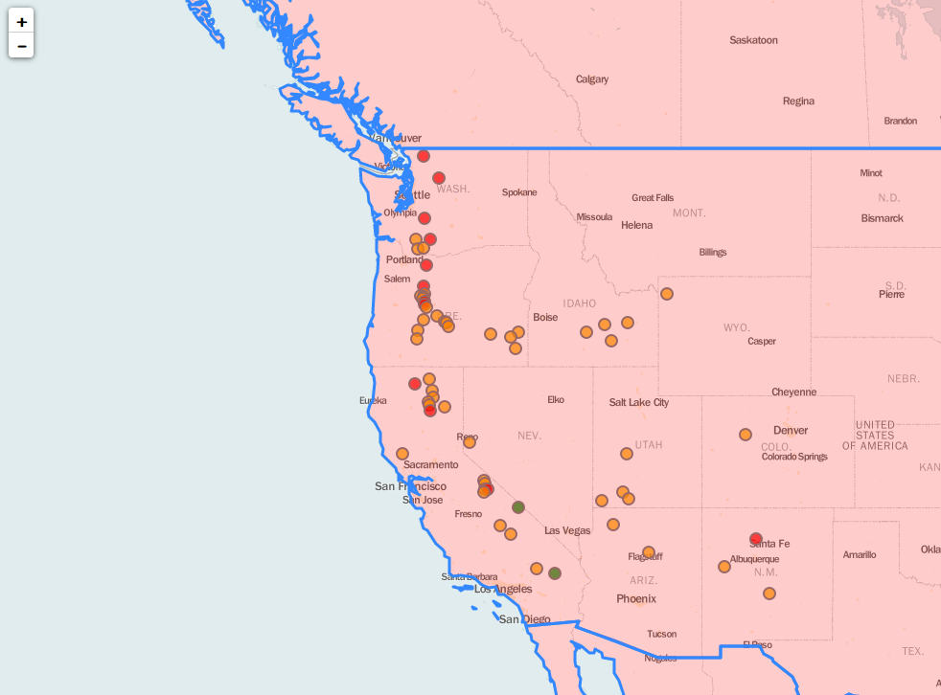

*\*There’s a tip in the next lecture.*